Introduction.
These illustrated notes are suggestions to augment the online instructions provided by Accurascale, based on my experience of doing it:
https://accuras.reamaze.com/kb/class-55-deltic/class-55-deltic-fitting-em-slash-p4-wheels
https://accuras.reamaze.com/kb/class-55-deltic/accurascale-class-55-deltic-bufferbeam-detail-fitting
https://accuras.reamaze.com/kb/class-55-deltic/how-to-remove-the-deltic-body

General points
The steps under the loco corners are very vulnerable. I had 2 loose when I unpacked the loco and they are in the line of fire here.
I found that I had a grille missing from one of the bogie side cab footsteps. It re-appeared and was easily refitted, so keep a look out for escaped parts.
I’m not usually a fan of Superglue, but it does seem to work well here.
You will probably not want to disconnect and re-connect the handbrake chains between the body and bogie more than once in your life, so I would advise that you plan ahead if you want to fit crew, change headcodes, change wheelsets etc.

Disassembly
Accurascale show removing the auto-coupling and pocket in one piece. I found it easier to pull the auto-coupling forward out of the pocket first. This gave easy access to the pocket with a pair of pliers to pull the pocket up and away from the bogie.
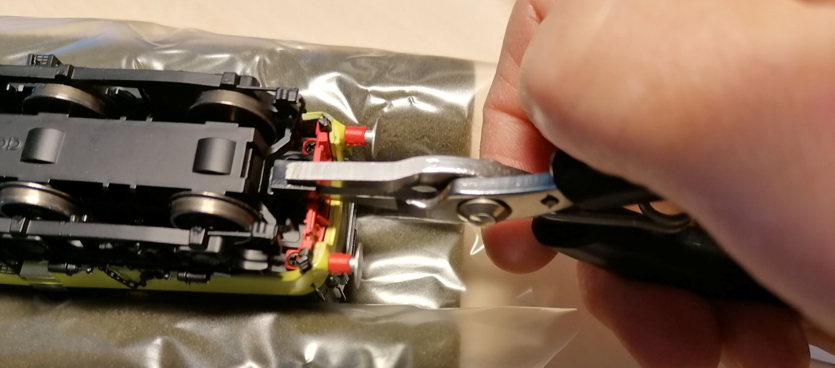
Accurascale suggest removing the brake chains from the loco body to allow removal of the keeper plate or loco body. Instead, I pulled the other end out of the bogie side as that seemed a bit more substantial. This wasn’t great; on 1 of 3 the chain pulled out of the bogie side bracket and has to be glued back in. In refitting the other 2 chains, one went back in easily, the other didn’t. For this one, I opened up the hole in the bogie side to 0.7mm (and now think 0.6 would be enough) and glued the end tab in with Evo-Stik which should be enough to hold it but also make it easy to pull apart later.
If you are careful, you should be able to just undo one chain and put the keeper plate on one side whilst re-wheeling. I did this for my second bogie.
The keeper plate has 2 central clips at the ends and 2 along each side. Once a clip is released, it stays that way which is a big help.
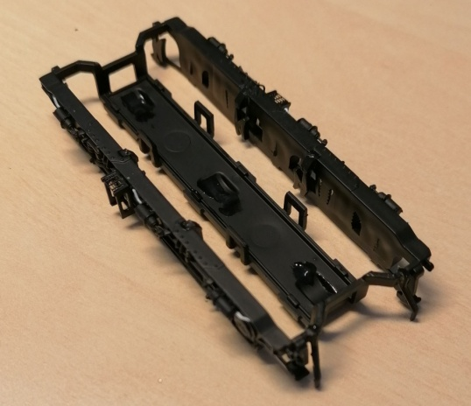
Accurascale’s photograph shows putting the screwdriver against the wheel and just inside the bogie frame to unclip the outboard end clip on the keeper plate. This may also pop the guard iron out, the other one in their photo is already missing. They can easily be re-glued if they do come off. I suggest starting at the inboard end to release the centre clip with the screwdriver against the axle inside the wheel rather than on the wheel tyre. Then move along releasing the 4 side clips. It should then be easy to hold the keeper plate and gently lever it off the outboard centre clip with the guard irons intact. Be careful if you still have one chain attached.
(Surprising given the level of detail included, it seems that the bogie sanding gear and pipes were too hard to include.)

Rewheeling
The wheelsets just lift out. I regauged the OO wheels from 14.5mm B2B to 16.5mm B2B. I understand that these wheels are about 0.5.mm wider than the EM replacement sets but as there is still about 1.8mm free space in total inside the bogie frames, I hope there is enough sideplay available. We’ll see.
When refitting the wheelsets, I clamped the pickups with self grip tweezers to make it easier.
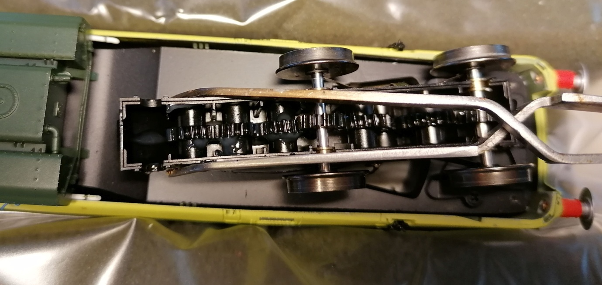

Buffer beam detailing
The instructions are fine. Just double check the positions of each item as it is easy to get confused. Some fit over the bottom; others sit in pockets on the front.
The Main Reservoir Air Pipes (Part H) are handed with the valve handle towards the centre on each side.
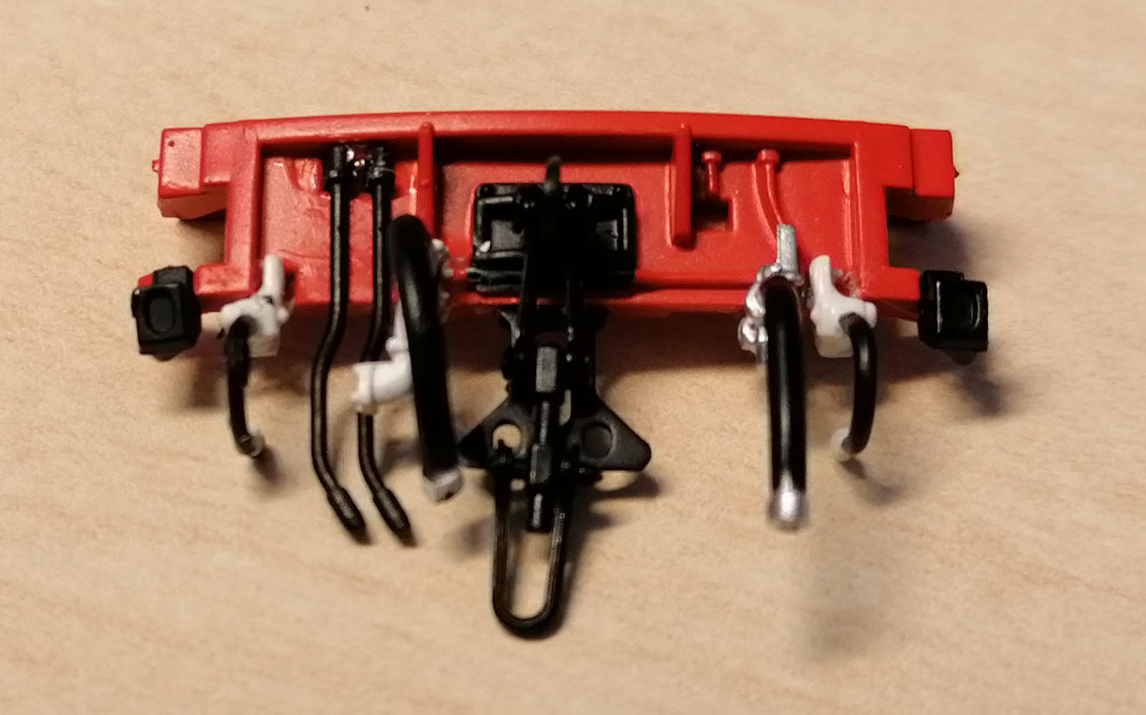

Plates
I’ve now fitted the etched plates as well. The works plates, although small, can be read and correctly represent those fitted to D9000 / 55022. I guess it was too much to ask to have a different set for each loco!

Photos
Here are a couple of photos of the regauged and detailed loco.
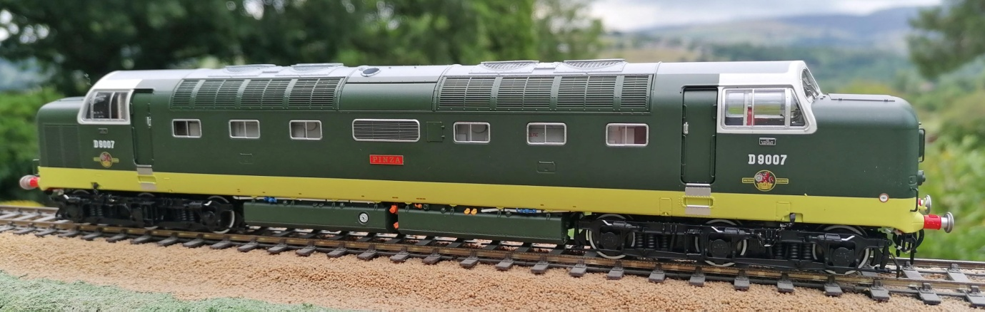
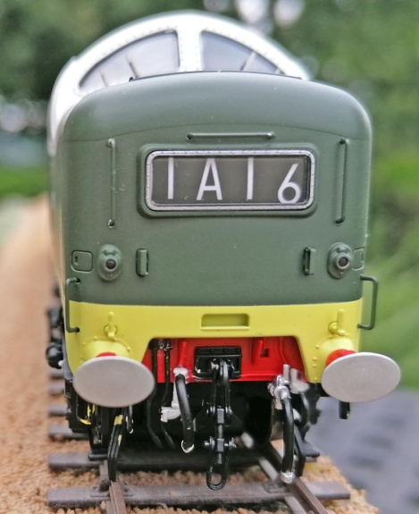

Summary
This isn’t too difficult, but is very fiddly. Re-connecting the chains had me use a loupe for the first time in a long time.
I had finished all the re-assembly and picked up the loco, only to find a brake shoe off one of the centre axle on the workbench, so I now need to try and refit this as well.
Beware that as I was putting the rear bogie on the track to take the photo, a brake cylinder came off. HANDLE WITH CARE.

